KENDRIYA VIDYALAYA NO.2 JALANDHAR CANTT
HOLIDAY HOMEWORK (AUTUMN BREAK)
(11-10-2021 TO 20-10-2021)

Class-1 Subject- Hindi
- पते ही पत्ते और बन्दर और गिलहरी पाठो की reading करनी है!
- झूला,आम की टोकरी,पकौड़ी, छुक छुक गाड़ी, रसोईघर, कविताए याद करनी है!

Class-1 Subject- English
1. Learn Phonic sounds of alphabet.
2. Read Unit 1,2 and 3.
3. Learn New Words and Rhyming words of all chapters.
4. Give stress on Reading.
5. Learn to speak few lines on Myself, My mother, My father.

Class-1 Subject- Maths
1. Learn Tables from 2 to 5.
2. Learn and write counting from 1 to 50.
3. Learn and write Number Names from 1 to 20.
4. Paste any 5 Shapes and learn and write the names of shapes.

Class-1 Subject- EVS
Paste pictures of following in your scrapbook -
1. Insects (Any 5)
2. Water animals (Any 5)
3. Wild animals (Any 5)
4. Pet animals (Any 5)
5. Birds (Any 5)

KENDRIYA VIDYALAYA NO.2 JALANDHAR CANTT
HOLIDAY HOMEWORK (AUTUMN BREAK)
(11-10-2021 TO 20-10-2021)

Class-II Subject- Hindi

1. 'तितली और कली' कविता को याद करो ।
2. मेरी किताब , तितली और कली पाठ की दोहराई करो।
3. तितली का चित्र बनाओ और तितली के बारे में पांच वाक्य लिखो।
4. वचन बदलो याद करो ।
5. चित्र वर्णन
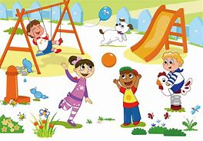
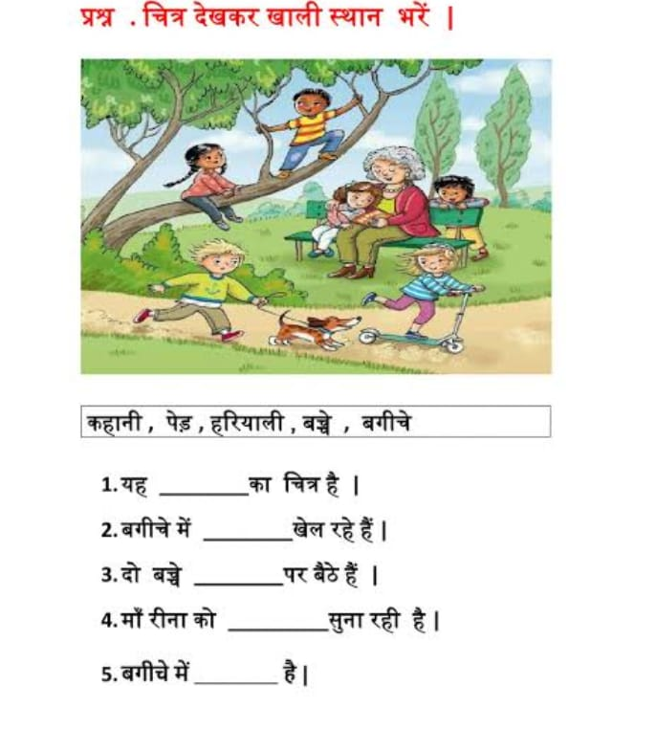
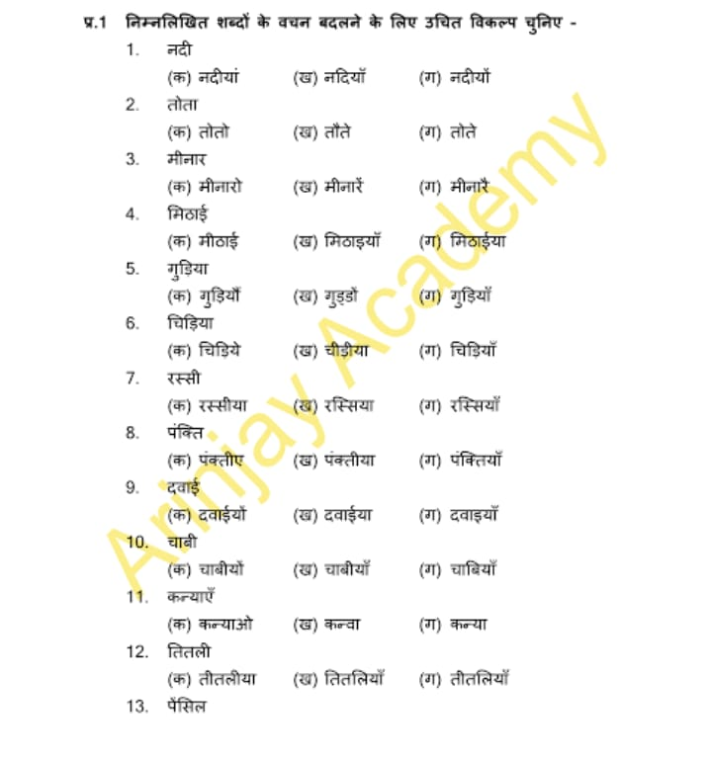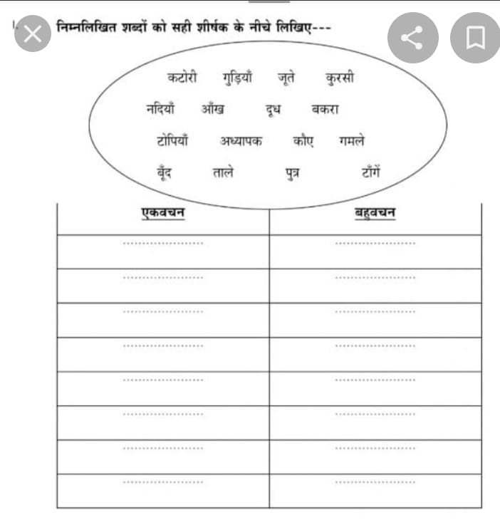

Class-II Subject- English
Q1. Read one page of your book daily.
Q2. Complete the given worksheets.

WORKSHEET 1

Q1
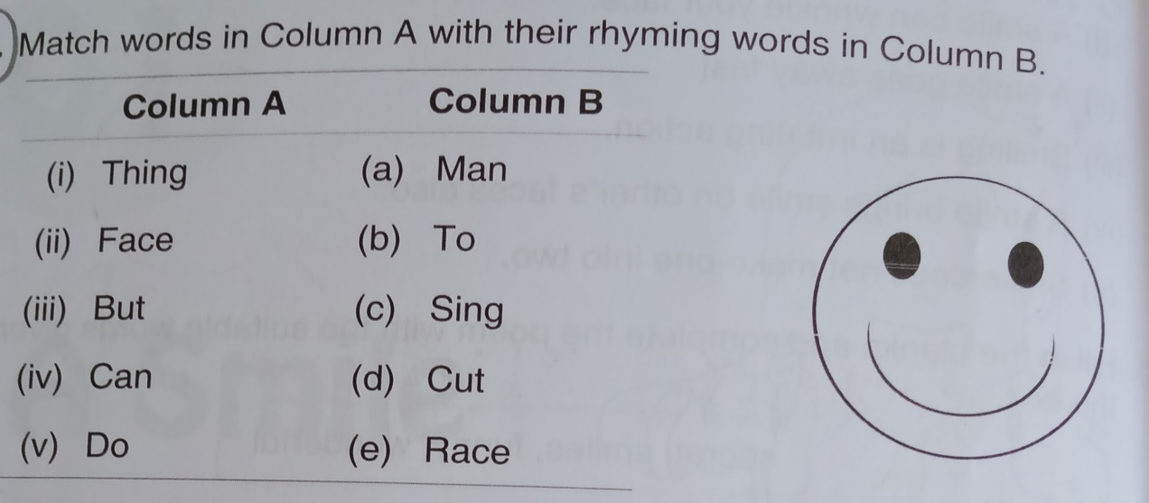

Q2

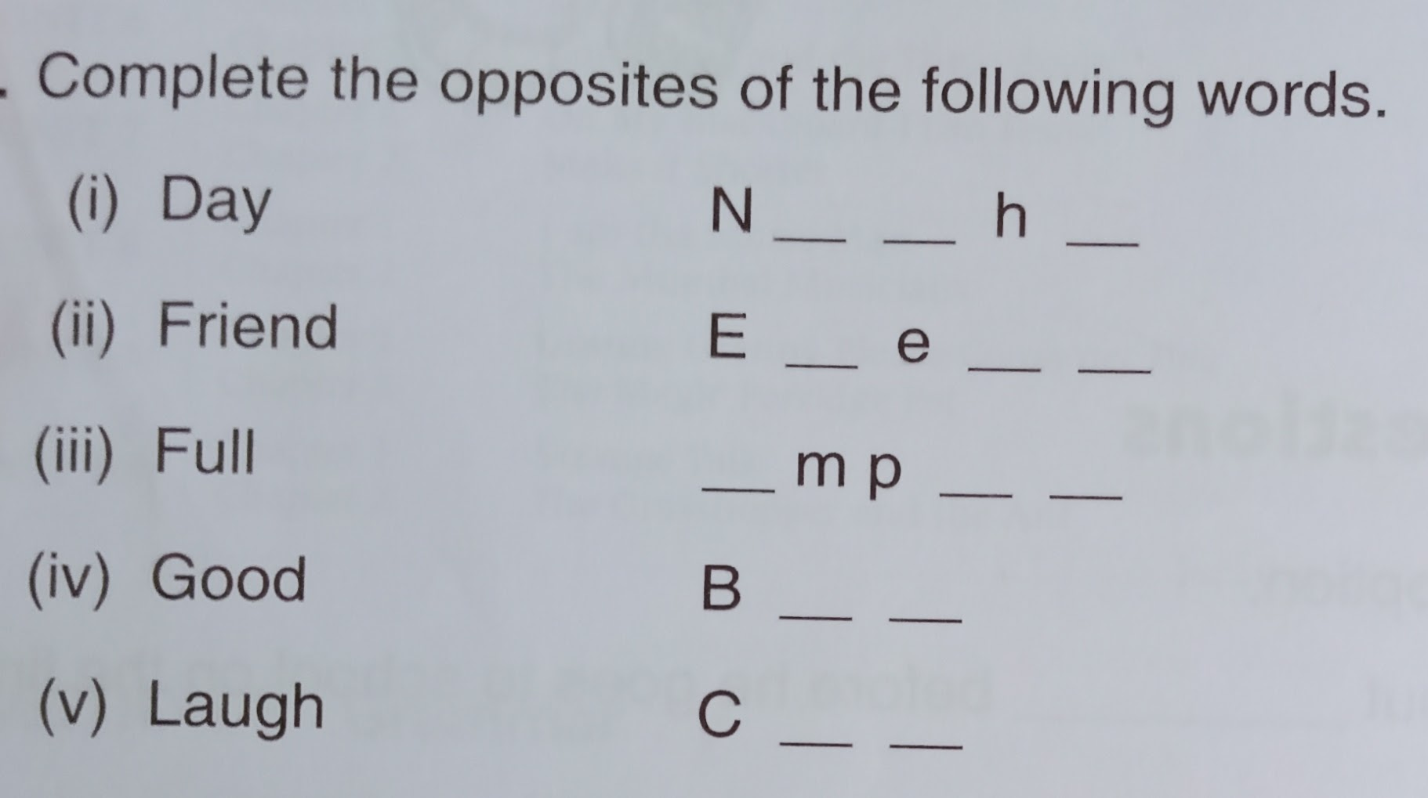

Q3.
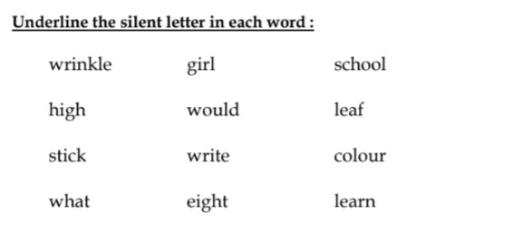

WORKSHEET 2

Q1.

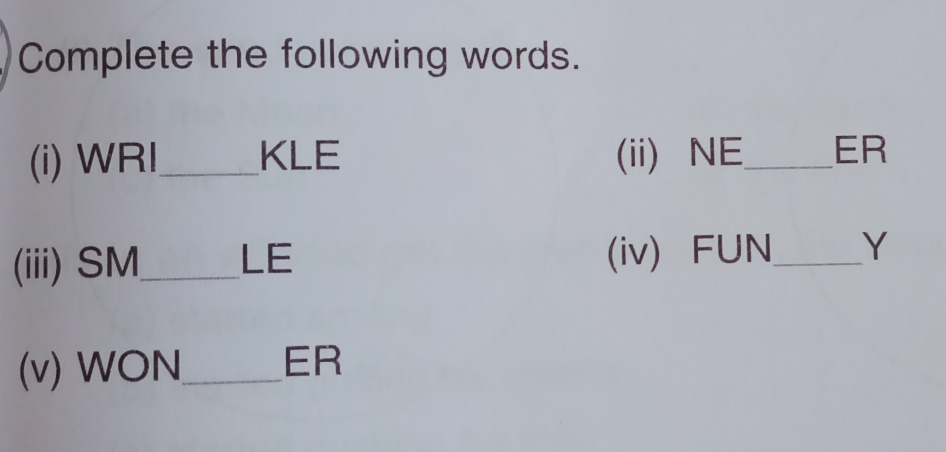

Q2.

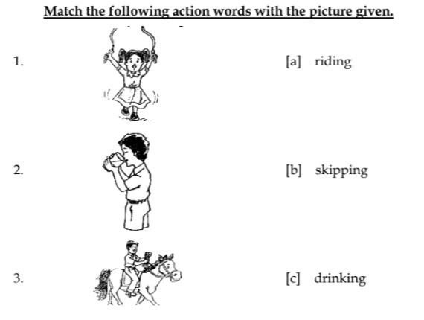
Q3.
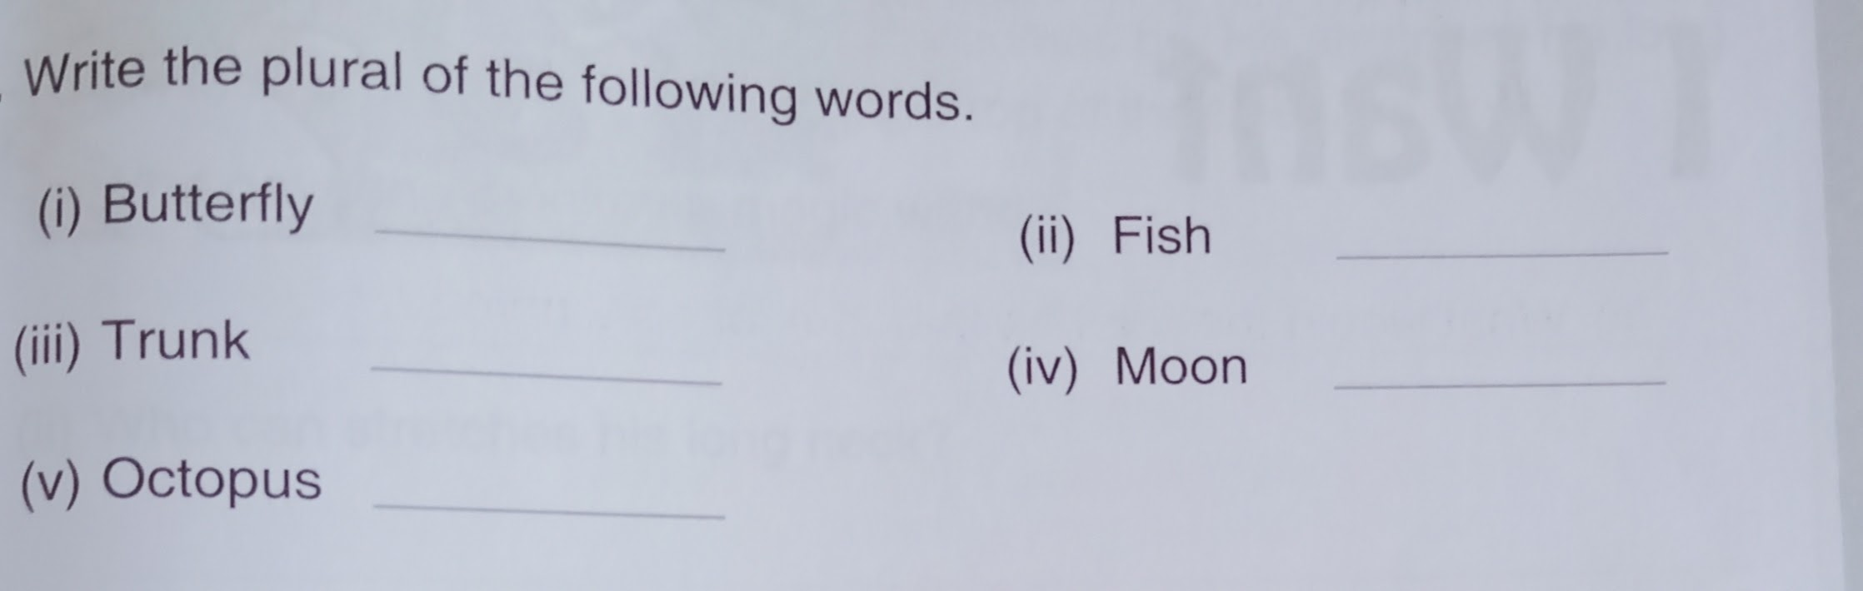
Q4.
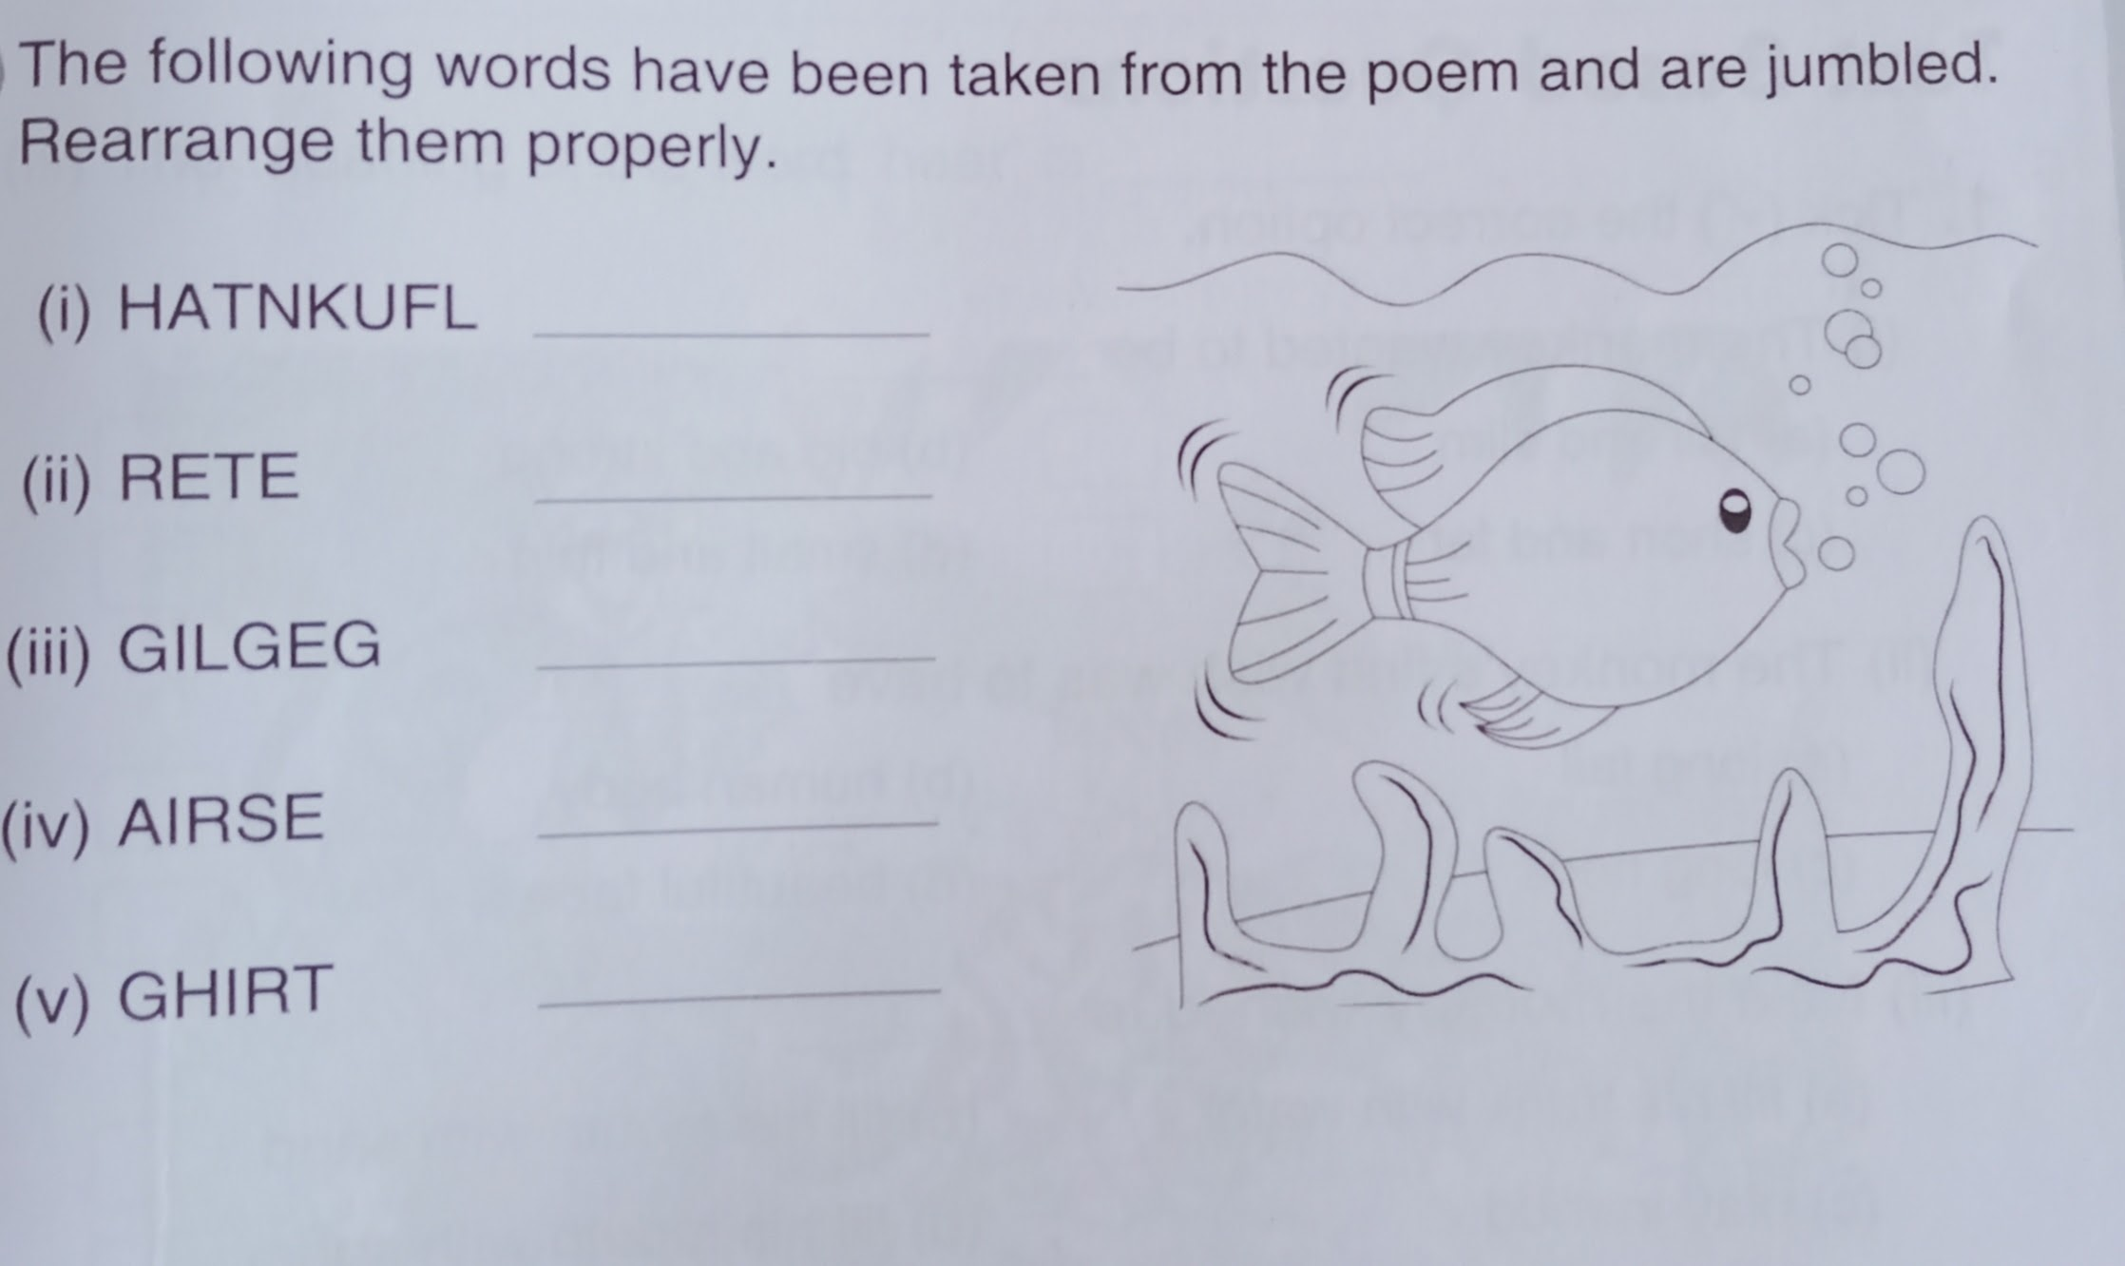
Colour the picture⬆️ too.

WORKSHEET 3

Q1.

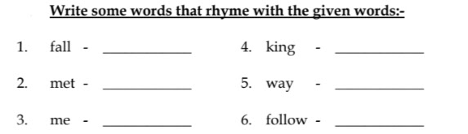
Q2. 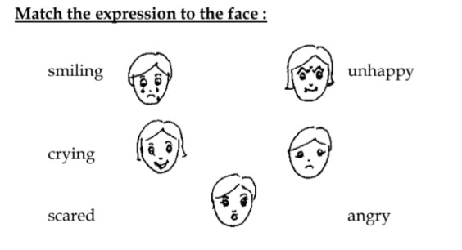
Q3.
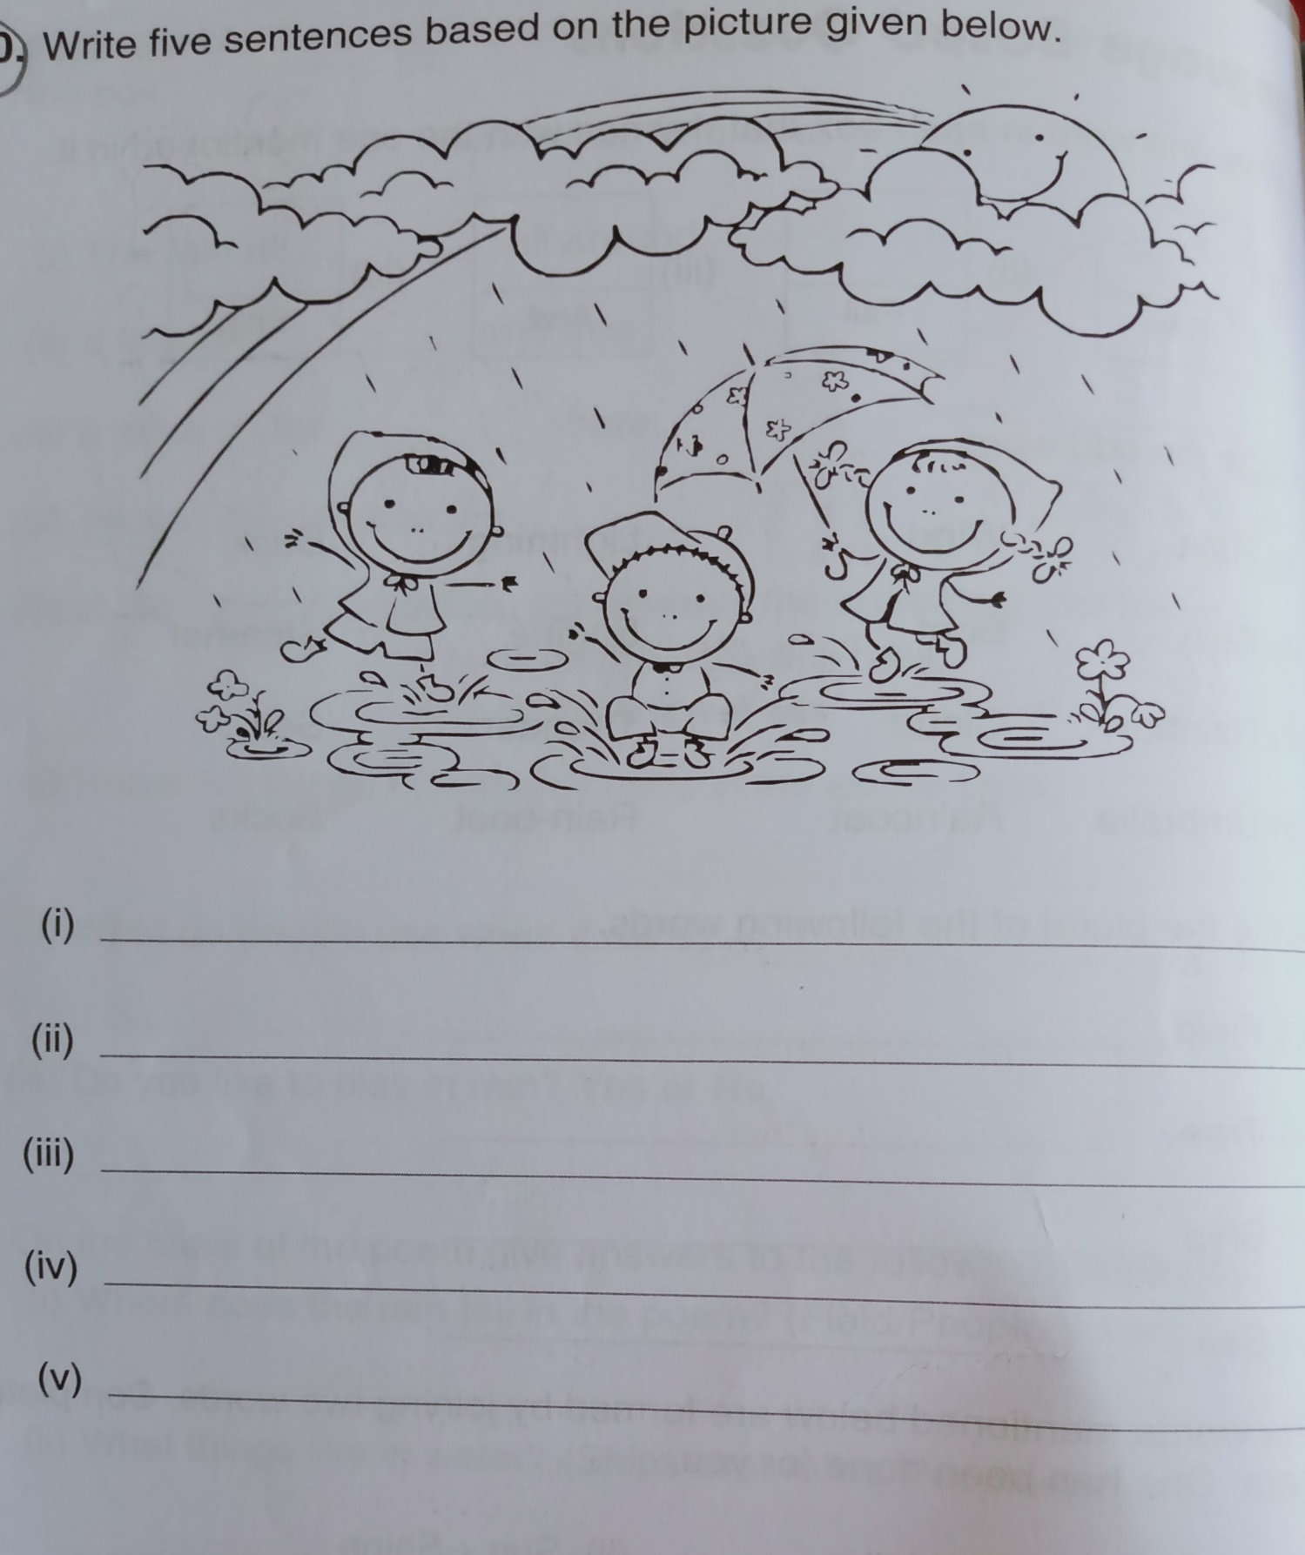
Colour the picture⬆️ too.

WORKSHEET 4
Q1. 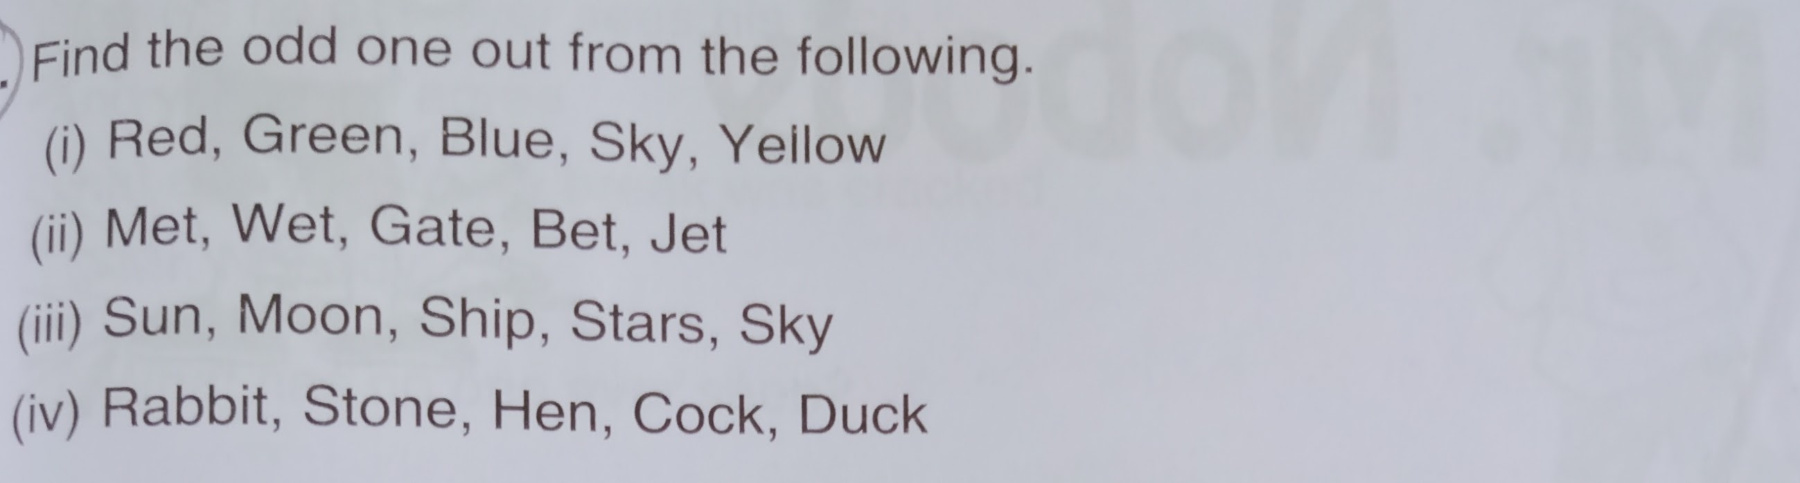
Q2. 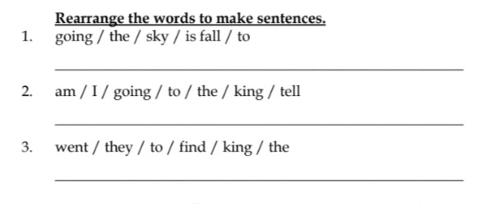
Q3. 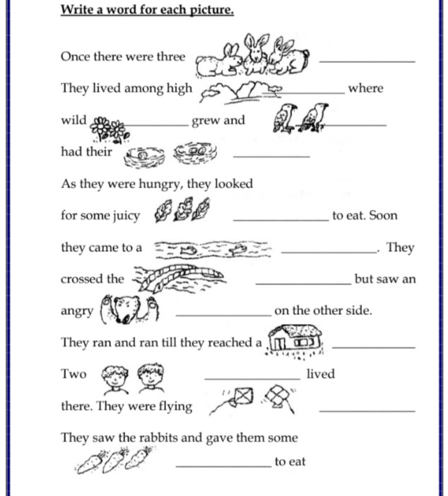

NOTE : THE HOLIDAYS HOMEWORK IS TO BE DONE IN A SEPARATE NOTEBOOK.

Class-II Subject- Maths
1. Learn the tables from 5 to 10
2. Revise the chapter-patterns, jug and mugs and tens and ones
3. Backward counting 300-100.
4. Do it on scrap book a) Draw 2D shapes and write their properties. (square rectangle triangle Pentagon hexagon) b) Make any two pictures with the help of shapes.
5. Worksheets
Class-II Subject- EVS

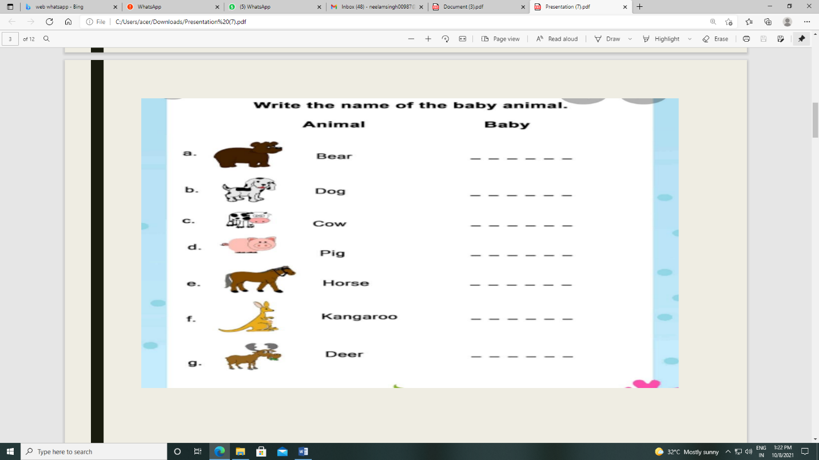

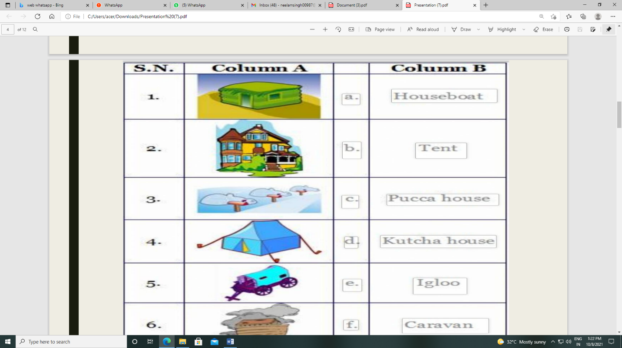

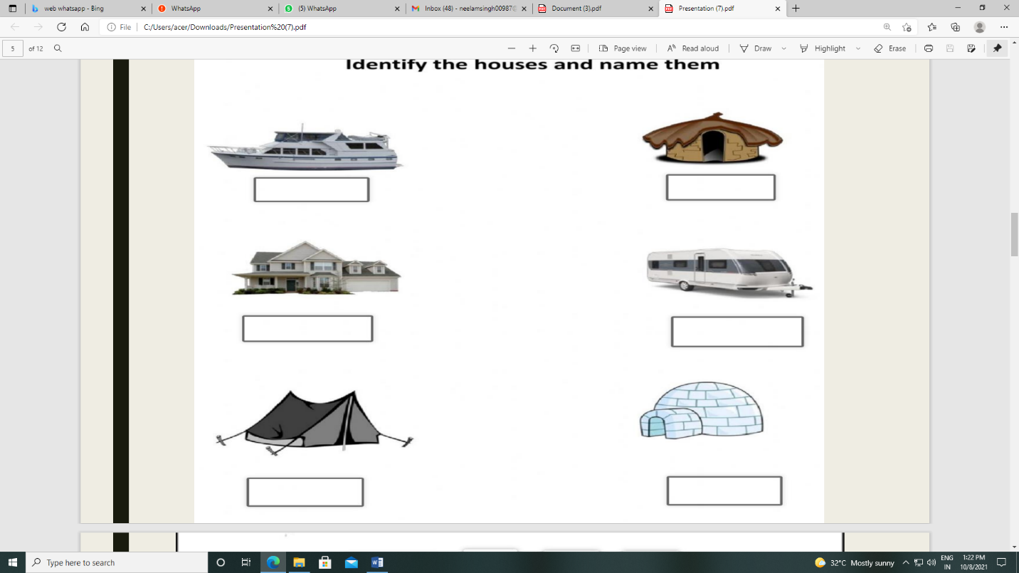

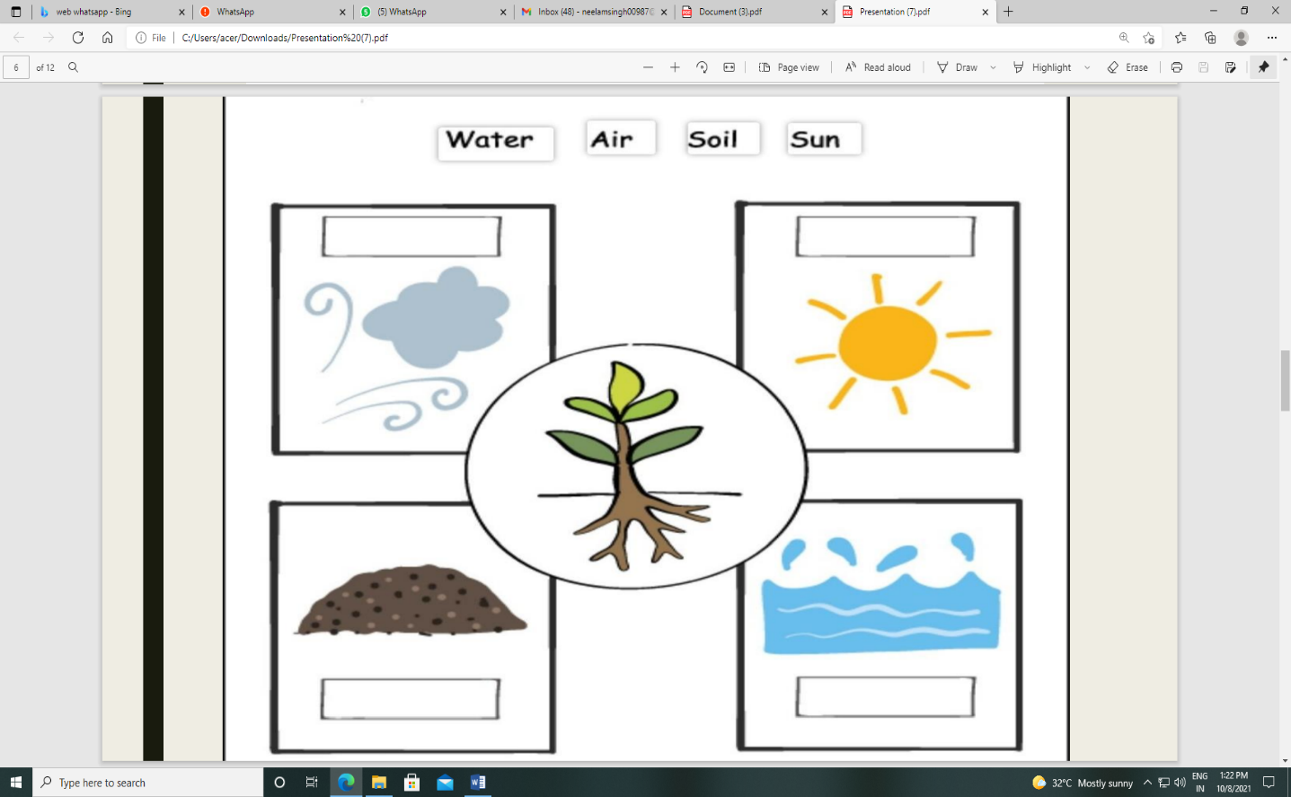

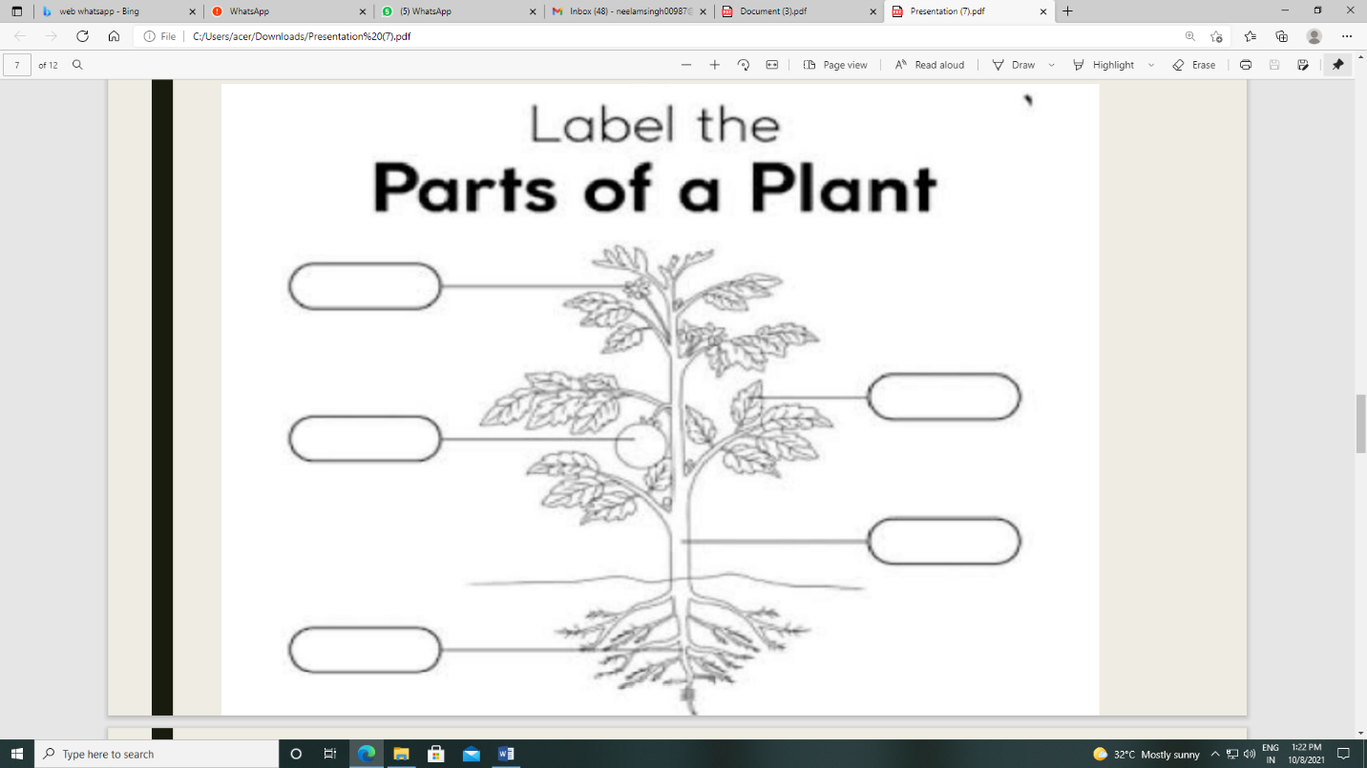

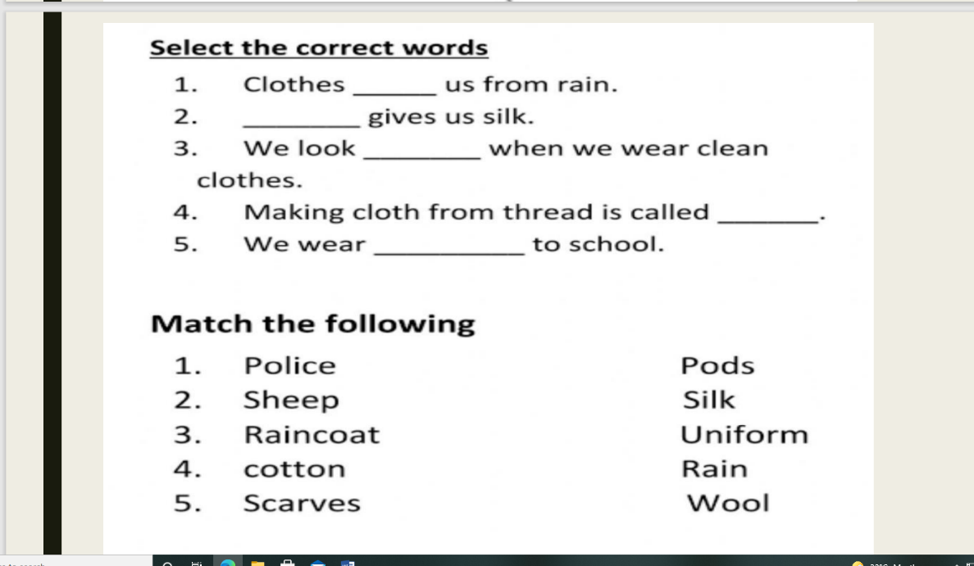

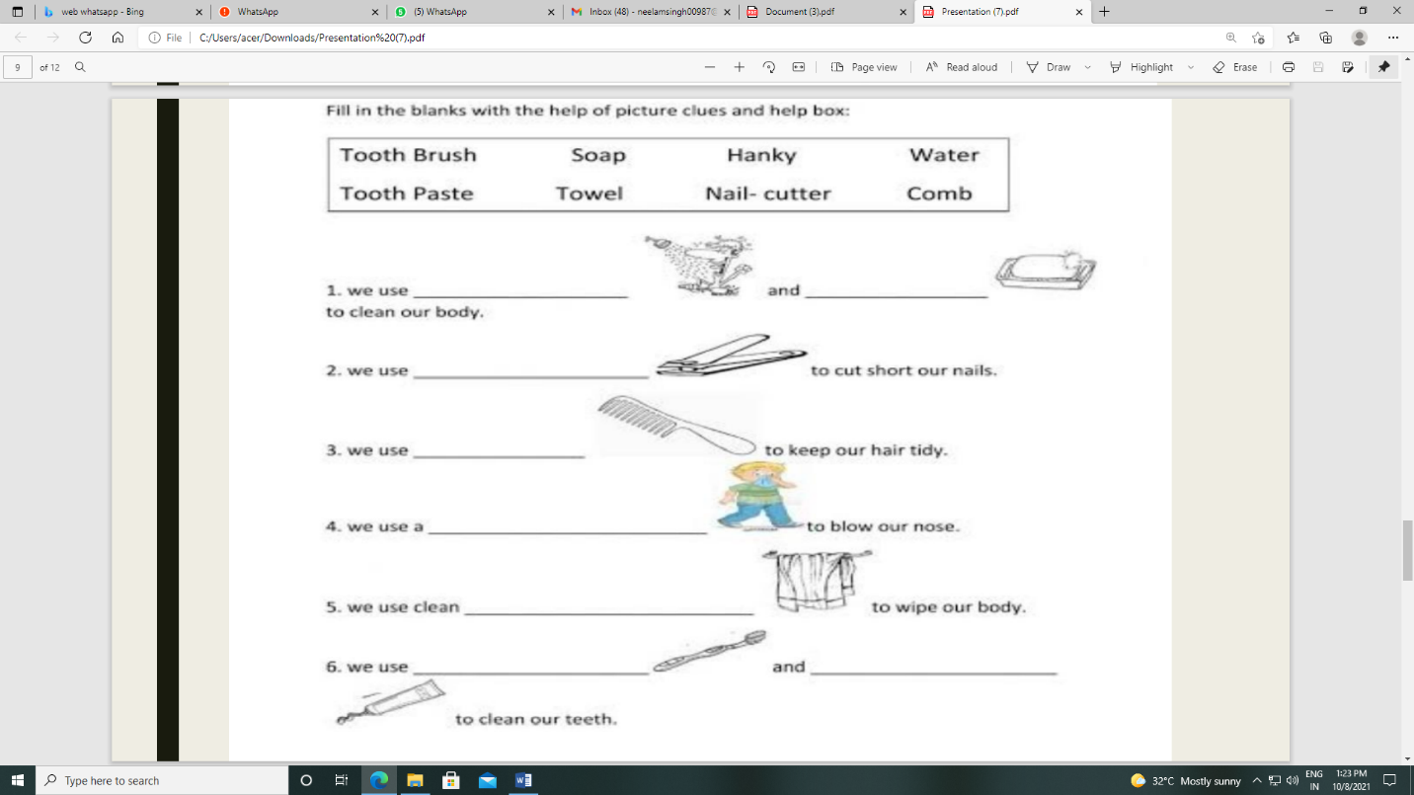

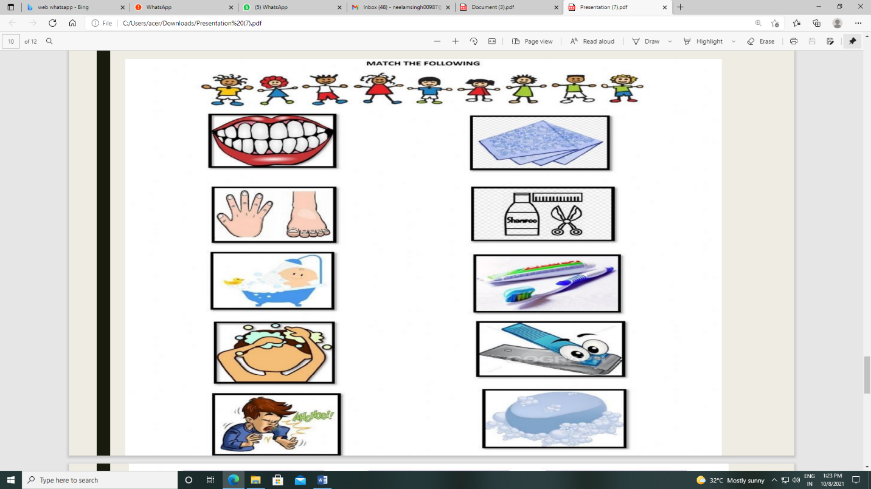
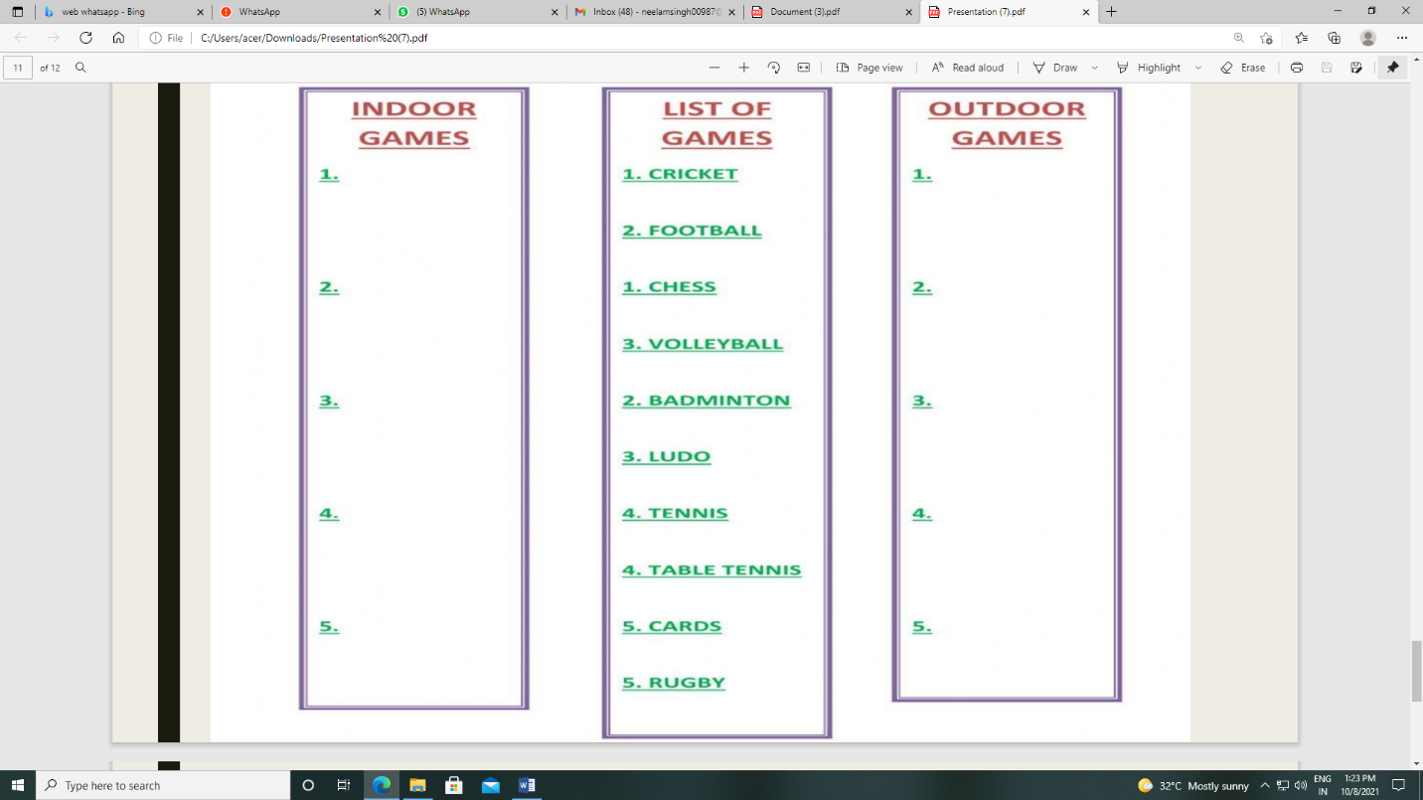

KENDRIYA VIDYALAYA NO.2 JALANDHAR CANTT
HOLIDAY HOMEWORK (AUTUMN BREAK)
(11-10-2021 TO 20-10-2021)

Class-III Subject- English
Project work -
In scrap book paste pictures of Wild animals
Pet animals, their homes (five of each group)
Write their names in Hindi as well as English, also write the names of wild life National Parks in India.

Revision of term 2 (Half yearly) Exams

1.Revise English book Page no 1 to Page no 52
2.All exercises done in English book as well as copies.
3.Learn few lines on Birds and trees.

Class-III Subject- Math’s

Revised half yearly syllabus for your exam which is chapter 1 to 7.
Also solve the given worksheet for your own practice.

Class-III Subject- EVS
1.learn all the syllabus of half yearly chapter 1 to 13

Project: - EVS list the food and vegetables grown above the ground and under the soil.
Art integration: - draw 10 fruits and vegetables
Math integration: - write the rate list of any ten vegetables
Language integration: - write following crop names name in English and Hindi: -
Rice
wheat
sugarcane
Jowar
Millet
Cotton
Barra
maize
gram
Groundnut
Class-III Subject- Hindi
✳️पाठ -1 से 9 तक का अभ्यास कार्य करो।
✳️अनुच्छेद - वर्षा ऋतु, कोयल , शेर , सूरज चांद पर वाक्य याद करो।
✳️10 जंगली और 10 पालतू जानवरों के चित्र चिपकाकर नाम लिखो।
✳️ रोटी बनाने की प्रक्रिया का चित्र सहित वर्णन करो।
KENDRIYA VIDYALAYA NO.2 JALANDHAR CANTT
HOLIDAY HOMEWORK (AUTUMN BREAK)
(11-10-2021 TO 20-10-2021)

Class-IV Subject- Hindi
पाठ :- 1 से 12 तक ( पिछले अभ्यास , शब्द अर्थ, नए शब्द सहित)
व्याकरण :- संज्ञा, सर्वनाम,विशेषण,क्रिया,लिंग, वचन,विलोम, पर्यायवाची, मुहावरे,
अपठित- पठित गद्यांश, अपठित - पठित काव्यांश
अनुच्छेद- स्वतंत्रता दिवस , रक्षा बंधन, वृक्षों की उपयोगिता, बीरबल पर वाक्य, मेरा प्रिय खेल।

Class-IV Subject- English

- Revise the term-1 syllabus.
- Multidisciplinary Project⬇️

Make your daily routine. Consider following points:
1. Wake up time:
2. Taking bath:

How much water your take to bath? From where the water come
from? Is water filtered? How can you save the water?
3. Break fast:

Which items do you eat?
Who does make these items?
Which materials are used to make them?
Is the food safe?
Where the food was cooked?

4. Study time:
5. Watching tv:

Which tv channel do you watch?
How much time do you watch the tv?
Which TV programme do you like?
6. Lunch time
7. Dinner time
8. Playing time:
9. Hobbies
10. Sleeping time

Class-IV Subject- Math’s
1. Revise Units 1 to 8 for Half yearly Exams
2. Make a Measuring Bottle of 2L using 200 ml small bottle.
3. Make any two beautiful designs with the help of compass in the scrap book

Class-IV Subject- EVS
Learn all the work done from lesson 1 (going to school) to lesson 14 (Basva’s Farm)
project work-
1.Paste any five pictures of birds and write their names in English as well as in Hindi.
2. Make a nest
3. What are the different functions of beaks of birds. make a small video and send to the class teacher.

KENDRIYA VIDYALAYA NO.2 JALANDHAR CANTT
HOLIDAY HOMEWORK (AUTUMN BREAK)
(11-10-2021 TO 20-10-2021)

Class-V Subject- Hindi
पाठ :- 1 से 10 तक ( पिछले अभ्यास , शब्द अर्थ, नए शब्द सहित)
व्याकरण :- संज्ञा, सर्वनाम,विशेषण,क्रिया,काल,लिंग, वचन,विलोम, पर्यायवाची, मुहावरे, अपठित - पठित
गद्यांश, अपठित – पठित काव्यांश
अनुच्छेद- मेरी मांँ, डाकिए पर वाक्य, मेरा प्रिय त्योहार, ईद, रक्षा बंधन।
Class-V Subject- English
Revise all the chapters from 1 to 10 with complete back exercise, question answers, synonyms and new words.
Class-V Subject- Maths
- Revise all the chapters from 1 to 7 for half yearly exams.
- Complete the work of Chapter- 8 in second term notebook.
- By taking a scale of 1 centimeter on map = 1 kilometer on ground, draw the route from your home to your school. Also, show all the important places on the way.
Class-V Subject- EVS
Revise all the Chapters from one to 10 for half yearly exams
Project work:
- Why do you call oil as liquid gold?
- Which country has largest oil reserves? Shade that country in the world map.
- Art integration: Draw logo of petrol, water and crude oil.
- Maths- Find the answers
  - Rate of 1-litre petrol……
  - Rate of 1 litre diesel……
  - Rate of 1 LPG cylinder…..
  - Meaning of Highway…..
- Hindi: Make a poster on “पेट्रोल बचाओ"

