KENDRIYA VIDYALAYA NO. 2 JALANDHAR CANTT
HOLIDAY HOME WORK 2021-22
SUBJECT ENGLISH
CLASS-X

- Reading : Read English newspaper and write any one news of your choice.
- Listening : English news.
- Read chapter 3&4 of both books and write the summary of the lessons.
- Five exercises each of rearrangement of jumbled words, editing, omission ( from any sample paper)
- Make a project file on
1 figure of speech with examples
2 Poem The Dust of Snow ,Fire and Ice, The Ball Poem, A Tiger in the Zoo(draw,summarize,comprehension)
3 Article on Road Safety, Environment Degradation, Health is wealth,
Water conservation ( 4 ARTICLES)
4 LETTER PLACING ORDER, COMPLAINT
(THIS PROJECT FILE WILL BE COUNTED AS INTERNAL ASSESSMENT FOR FINAL EXAM OF CLASS 10 MARKS ALLOTTED 20)

केन्द्रीय विद्यालय क्रमांक 2 जालंधर छावनी
ग्रीष्म-कालीन अवकाश (सत्र 2021-22)
हिन्दी:
- माता का आँचल’ पाठ के आधार पर एक परियोजना कार्य तैयार कीजिए जिसमें भोलानाथ के जीवन से संबंधित जानकारी,उनके खेल व खेलने कि सामग्री, आपके खेल व खेल कि सामग्री,दोनों के बीच व्याप्त अंतर बताते हुए चित्र सहित वर्णन कीजिए |
नोट। (यह परियोजना कार्य ही आपके अंकों का आधार होगा )
- सूरदास के पदों का भावार्थ लिखिए |
- संज्ञा,सर्वनाम,विशेषण,कारक,लिंग,वचन,अव्यय व काल के भेदों कि परिभाषा देते हुए दो- दो उदाहरण लिखिए |
- अपने मित्र को ऑनलाइन कक्षा की गुणवता बताते हुए कक्षा लगाने की सलाह देते हुए पत्र लिखिए |
- आवधिक परीक्षा-1 की तैयारी के लिए जितना पाठ्यक्रम कराया गया उसकी दोहराई कीजिए |

HOLIDAY HOME WORK
CLASS X
MATHEMATICS
- Learn table 2 to 25.
- Complete your homework and class work copy up to covered syllabus.
- Solve all solved examples from chapter’s Real Numbers, Polynomials and Linear equation in two.
- Solve the following questions
- The numbers 525 and 3000 are both divisible only by 3, 5, 15, 25 and 75. What is HCF (525, 3000)?
- Show that the square of an odd positive integer is of the form 8m + 1, for some whole number m.
- Prove that one and only one out of n, n + 2 and n + 4 is divisible by 3, where n is any positive integer.
- Prove that $\sqrt{3}$ is an irrational number.
- State fundamental theorem of Arithmetic and hence find the unique factorization of 120,154& 512.
- Prove that $\sqrt{3}$ + $\sqrt{5}$ is irrational
- Prove that5 – $\frac{3}{7}\sqrt{3}$is an irrational number.
- If one root of the polynomial P(x) = 5$x^{2}$ + 13$x$ + $k$ is reciprocal of the other, then find value of k.
- If one zero of the quadratic polynomials $x^{2}$ + 3$x$+ k is 2, then find value of k.
- If the zeroes of the quadratic polynomial $x^{2}$ + (a + 1)x + b are 2 and – 3, then find $a$ & b.
- If α and β are the zeroes of the polynomial f (x) = $x^{2}$ + $x$ + 1, then find $\frac{1}{α}+\frac{1}{β}$.
- If α and β are zeros of polynomial 6$x^{2}$ – 7$x$ – 3, then form a quadratic polynomial where zeros are 2α & 2β.
- If the lines given by 3x + 2ky = 2 and 2x + 5y = 1 are parallel, then the value of k is _______ .
- If x = a and y = b is the solution of the equation x – y = 2 and x + y = 4, then the values of a and b are respectively _______ .
- What is the point of intersection of the line represented by 3x – 2y = 6 and the y-axis?
- For what value of p, system of equations 2x + py = 8 and
x + y = 6 have no solution.
- Find the value of k for which pair of linear equations 3x + 2y = –5 and x – ky =2 has a unique solution.
- Check whether the graph of the pair of linear equations x + 2y – 4 = 0 and 2x +4y – 12 = 0 is intersecting lines or parallel lines.
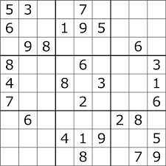
- Solve the following sudoku :-
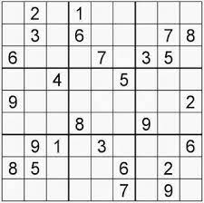

CLASS X Science
- Solve the CCT assignment
https://drive.google.com/file/d/1s8rLT1G-HIE7HGvKK5YOoXUMN22L_2GE/view?usp=sharing

- Make a 2-minute video performing any science activity of your choice from your NCERT book.
- Think over something new innovative idea of your own that is helpful in today’s society. And prepare a write up of it. Students who will do this task too will get extra marks.
- Think of a science fiction story and pen it down.
- Write one science news of each week during the holidays.
- Find out minimum 5 scientific happenings on your birthday.
- INTERNAL ASSESSMENT
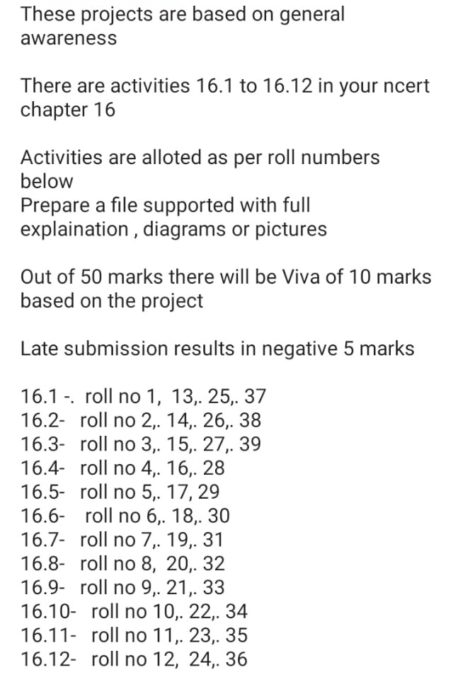
- Suppose you got a chance to become teacher for one day and you have to teach your classmates about the topic given in front of your name in the list below. So write what you will speak in front of your classmates. You can also use pictures, diagrams, story, or some examples to make your topic interesting.(So don’t just copy paste from anywhere, use simple language and simple words that could be easily understood by your classmates)(Those who have got scientist as their topic, they will find about funny or inspiring incidents about them)

Topic should be between 2-4 pages. but it should be informative and interesting and simple to understand.

S.NO TOPIC
CLASS 10 SECTION A
1 Hydrogen
2 Helium
3 Lithium
4 Brass
5 Boron
6 Carbon
7 Nitrogen
8 Oxygen
9 Flourine
10 Neon
11 Sodium
12 Magnesium
13 Aluminium
14 Silicon
15 Phosphorus
16 Sulphur
17 Chlorine
18 Argon
19 Potassium
20 Calcium
21 Bronze
22 Nichrome
23 Duralumin
24 Chromium
25 Maganese
26 Iron
27 Cobalt
28 Nickle
29 Copper
30 Zinc
31 Stainless steel
32 Steel
33 Solder wire
34 ALNICO
35 Bromine
36 Amalgam
37 Silver
38 Quick Lime
39 Tin
40 Iodine
41 Aqua Regia
42 Barium
43 Tungesten
44 Baking Powder
45 Platinum
46 Gold
47 Mercury
48 Lead
49 Radium
50 Uranium
51 Ammonia

CLASS 10 SECTION B
1 Mercury
2 Venus
3 Earth
4 Mars
5 Jupiter
6 Saturn
7 Uranus
8 Neptune
9 Pluto
10 Meteors and meteorites
11 Asteroids
12 Sun
13 Moon
14 Moons of other planets
15 Artificial satellites
16 Constellations
17 Comets
18 Eclipse
19 Louis Pasteur
20 Alexendar Fleming
21 Edward Jenner
22 Issac Newton
23 Einstein
24 Robert Hooke
25 Hans Christian Oersted
26 Thomas Alva Edison
27 Gregor Mendel
28 Charles Darwin
29 Joule
30 Simon Ohm
31 Michael Faraday
32 Fleming
33 Alfred Nobel
34 Archemidies
35 Ampere
36 Rutherford
37 Neil Bohr
38 C V Raman
39 Elon Musk
40 Benjamin Franklein
41 Steve Jobs
42 Peter Higgs
43 Alexander Graham Bell
44 CNR Rao
45 Satyandra Nath Bose
46 Robert Boyle
47 Kelvin
48 Sunder Pichai
49 James Chadwick
50 J J Thomson
CLASS 10 SECTION C
1 John Dalton
2 Coulomb
3 Mary Curie
4 Galilio Galili
5 Christian Barnard Shaw
6 Bleaching powder
7 Stephen Hawking
8 APJ Abdul Kalam
9 Edwin Hubble
10 Lamarck
11 Lavousier
12 Leonardo Da Vinci
13 Maxvell
14 Henry Mosley
15 Sameul Morse
16 Ostwald
17 Haber
18 Pascal
19 William Roentegon
20 Ronald Ross
21 Volta
22 James Watt
23 COVID
24 SARS
25 HIV

SUBJECT- SOCIAL SCIENCE

1. PROJECT WORK
Topic :
Consumer awareness or social issue or sustainable development
2. Write extra 15 MCQ and 2 competency based (passive based) questions answers from chapter
History( Rise of nationalism in Europe)
Geography ( Resources and development)
Economics (Development)
Political science ( Power sharing)
3. Map work
Draw political map with states and capital name on outline map of India.
Show France, Germany, Russia, Poland, Balkan state, Austria on political map of Europe.

ਕੇਂਦਰੀਆ ਵਿਦਿਆਲਿਆ ਨੰਬਰ -2 ਜਲੰਧਰ ਕੈਂਟ

ਕਲਾਸ -10ਵੀਂ
ਵਿਸ਼ਾ-ਪੰਜਾਬੀ
ਛੁੱਟੀਆਂ ਦਾ ਕੰਮ (ਪ੍ਰੋਜੈਕਟ)
2021-2022

ਪੱਤਰ ਕੋਈ ਚਾਰ ਕਰੋ,
* ਆਪਣੇ ਮਿੱਤਰ ਨੂੰ ਕਿਸੇ ਪ੍ਰੀਖਿਆ ਵਿੱਚ ਮੋਹਰੀ ਦਰਜਾ ਪ੍ਰਾਪਤ ਕਰਨ ਤੇ ਵਧਾਈ ਪੱਤਰ
* ਰਿਸ਼ਤੇਦਾਰ / ਮਿੱਤਰ ਦੇ ਘਰ ਕਿਸੇ ਵਿਆਕਤੀ ਦੀ ਮੌਤ ਤੇ ਅਫਸੋਸ ਪੱਤਰ
* ਵਿਦੇਸ਼ ਰਹਿੰਦੇ ਰਿਸ਼ਤੇਦਾਰ ਨੂੰ ਪਿੰਡ ਵਿੱਚ ਆਈਆਂ ਤਬਦੀਲੀਆਂ ਬਾਰੇ ਪੱਤਰ
* ਮਿੱਤਰ ਦੀ ਭੈਣ ਦੇ ਵਿਆਹ ਤੇ ਨਾ ਸ਼ਾਮਲ ਹੋ ਸਕਣ ਸੰਬੰਧੀ ਪੱਤਰ
* ਮਿੱਤਰ / ਸਹੇਲੀ ਨੂੰ ਪੜ੍ਹਾਈ ਅਤੇ ਖੇਡਾਂ ਵਿੱਚ ਬਰਾਬਰ ਦਿਲਚਸਪੀ ਲੈਣ ਲਈ ਪੱਤਰ
* ਤੁਹਾਡਾ ਰਿਸ਼ਤੇਦਾਰ ਤੁਹਾਨੂੰ ਪਾਸ ਹੋਣ ਤੇ ਸੁਗਾਤ ਦੇਣੀ ਚਾਹੁੰਦਾ ਹੈ ਆਪਣੀ ਰੁਚੀ ਅਨੁਸਾਰ ਸੁਝਾਅ ਦਿਓ
* ਪ੍ਰਦੂਸ਼ਣ ਦੀ ਸਮੱਸਿਆਂ
* ਸ਼ਹੀਦ ਭਗਤ ਸਿੰਘ
* ਕਰਤਾਰ ਸਿੰਘ ਸਰਾਭਾ
* 15 ਅਗਸਤ-ਸੁੰਤਤਰਤਾ ਦਿਵਸ
* ਸੰਚਾਰ ਦੇ ਸਾਧਨ
* ਸਾਡੇ ਮੇਲੇ ਅਤੇ ਤਿਉਹਾਰ
ਲੇਖ-ਰਚਨਾ👆ਕੋਈ ਚਾਰ ਕਰੋ।
ਸਾਹਿਤ-ਮਾਲ਼ਾ-ਗੁਰੂ ਨਾਨਕ ਦੇਵ ਜੀ (ਸੋ ਕਿਉ ਮੰਦਾ ਆਖੀਐ)ਇੱਕ ਸ਼ਬਦ ਵਾਲੇ 15 ਪ੍ਰਸ਼ਨ ਉੱਤਰ ਬਣਾਓ।
ਵਾਰਤਕ- 'ਘਰ ਦਾ ਪਿਆਰ ' ਪ੍ਰਿ:ਤੇਜਾ ਸਿੰਘ ਦੇ 15 ਬਹੁ-ਵਿਕਲਪੀ ਬਣਾਓ।

HOLIDAYS HOMEWORK ART EDUCATION
1 landscape
2. Still life in pencil shading
3 Poster on Save Environment
4. Painting on traditional art of India Any one:
Kalamkari painting
Madhubani painting
Warli painting
Gond painting
5. Any craft item
6. Paper collage
7. Poster on covid-19

