KENDRIYA VIDYALAYA NO. 2 JALANDHAR CANTT
HOLIDAY HOME WORK 2021-22
SUBJECT ENGLISH
CLASS-IX

- Reading : Read English newspaper and write any one news of your choice.
- Listening : English news.
- Read chapter 3&4 of both books and write the summary of the lessons.
- Five exercises each of rearrangement of jumbled words, editing, omission ( from any sample paper)
- Make a project file on
1 figure of speech with examples
2 Poem The Road Not Taken and WIND (draw,summarize,comprehension)
3 Article on ROAD SAFETY, ENVIRONMENT DEGRADATION,HEALTH IS WEALTH,
Water conservation ( 4 ARTICLES)
4 LETTER PLACING ORDER, COMPLAINT

केन्द्रीय विद्यालय क्रमांक 2 जालंधर छावनी
ग्रीष्म-कालीन अवकाश (सत्र 2021-22)
हिन्दी: कक्षा : नौवीं
- ‘ल्हासा कि ओर’ पाठ के आधार पर एक परियोजना कार्य तैयार कीजिए जिसमें आपने वहाँ की भौगोलिक विशेषताएं,सांस्कृतिक,वेशभूषा,कानून व्यवस्था आदि की जानकारी हासिल कर चित्र सहित वर्णन कीजिए व अपनी किसी अविस्मरणीय यात्रा से संबंधित जानकारियों का भी वर्णन कीजिए |
नोट- (यह परियोजना कार्य ही आपके आंतरिक अंकों का आधार होगा )
- कबीरदास की साखियों व सबद का भावार्थ लिखिए |
- संज्ञा,सर्वनाम,विशेषण,कारक,लिंग,वचन,अव्यय व काल के भेदों कि परिभाषा देते हुए दो- दो उदाहरण लिखिए |
- कबीरदास व रसखान जी के बारे में (8-8) पंक्तियाँ लिखिए |
- इस जल प्रलय में पाठ के आधार पर बाढ़ से बचने के कोई दस उपाय लिखिए |
- अपने मित्र को ऑनलाइन कक्षा की गुणवता बताते हुए कक्षा लगाने की सलाह देते हुए पत्र लिखिए |
- आवधिक परीक्षा-1 की तैयारी के लिए जितना पाठ्यक्रम कराया गया उसकी दोहराई कीजिए |

Holidays homework of class 9 MATHS
Q.1 Make project on any of one following topic
a).Define rational and irrational numbers with examples and write down the
differences between them.
b)Make chart on different identities
c)Define, polynomials and it’s various terms
Q.2 solve following questions
a)Express 1.363636… in the form pq, where p and q are
integers and q ≠ 0.
b)Simplify and find the value of(a) (729)¹/⁶(b) (64)²/³
c)Operation on real numbers & Algebraic identities-If x =
3−√13÷2, what is the value of x²+1/x²
d)Rationalise the denominator 1/9+√5+√6
e)Factorize the given expression:27x³ - 63x² + 49x – 343/27
f)Without actual division prove that (x² - x - 2) divides 2x⁴ + x³ -
5x² - 8x – 4
g)x² – x is ________ polynomial.
a. Linear b. Quadratic c. Cubic d. None of the above
Q.3 solve the puzzle
If A is substituted by 4, B by 3, C by 2, D by 4, E by 3, F by 2 and
so on, then what will be total of the numerical values of the
letters of the word SICK?
A) 11
B) 12
C) 10
D) 9
Also revise chapter 1 and 2 solve all questions on holiday
homework copy

CLASS IX Science
- Solve the CCT assignment
https://drive.google.com/file/d/1s8rLT1G-HIE7HGvKK5YOoXUMN22L_2GE/view?usp=sharing

- Make a 2-minute video performing any science activity of your choice from your NCERT book.
- Think over something new innovative idea of your own that is helpful in today’s society. And prepare a write up of it. Students who will do this task too will get extra marks.
- Think of a science fiction story and pen it down.
- Write one science news of each week during the holidays.
- Find out minimum 5 scientific happenings on your birthday.
- INTERNAL ASSESSMENT PROJECT

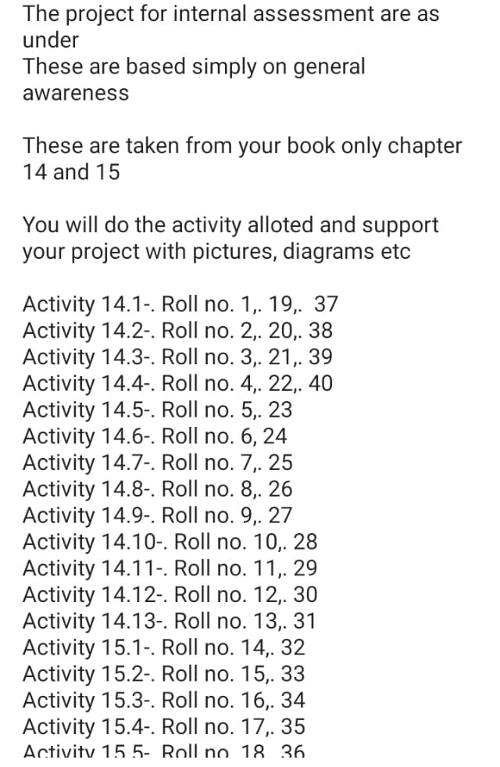
- Suppose you got a chance to become teacher for one day and you have to teach your classmates about the topic given in front of your name in the list below. So write what you will speak in front of your classmates. You can also use pictures, diagrams, story, or some examples to make your topic interesting.(So don’t just copy paste from anywhere, use simple language and simple words that could be easily understood by your classmates)(Those who have got scientist as their topic, they will find about funny or inspiring incidents about them)

Topic should be between 2-4 pages. but it should be informative and interesting and simple to understand.

SOCIAL SCIENCE HOLIDAY HOMEWORK
CLASS IX
- Make a project on disaster management. It should include the topic on covid 19 situation in India also.
- Make five short answer type question answers from each completed chapters (4×5=20).
- Paste the map work on the chapter India size and location.
- You have to make question answers from the paragraph given to you from the completed chapters of your textbook.
- Make a small video on the Indian national movement.
- Revise all the chapters that have completed and read the chapters at least twice.

ਕਲਾਸ - 9ਵੀਂ
ਵਿਸ਼ਾ -ਪੰਜਾਬੀ

ਪੱਤਰ ਕੋਈ ਚਾਰ ਕਰੋ।👇
* ਆਪਣੇ ਪਿੰਡ ਦੇ ਸਰਪੰਚ ਨੂੰ ਮੁੱਹਲੇ ਦੀ ਸਫ਼ਾਈ ਅਤੇ ਗੰਦੇ ਪਾਣੀ ਦੇ ਪ੍ਰਬੰਧ ਨੂੰ ਸੁਧਾਰਨ ਲਈ ਪੱਤਰ।
* ਮਿੱਤਰ ਨੂੰ ਸਕੂਲ ਦੀਆਂ ਵਿਸ਼ੇਸ਼ਤਾਵਾਂ ਦੱਸਦੇ ਹੋਏ ਦਾਖ਼ਲਾ ਲੈਣ ਲਈ ਪ੍ਰੇਰਿਤ ਕਰਨ ਲਈ ਪੱਤਰ ਲਿਖੋ।
* ਛੋਟੇ ਭਰਾ ਨੂੰ ਪੜ੍ਹਾਈ ਅਤੇ ਖੇਡਾਂ ਵਿੱਚ ਬਰਾਬਰ ਹਿੱਸਾ ਲੈਣ ਲਈ ਪੱਤਰ।
* ਪੋਸਟ ਮਾਸਟਰ ਨੂੰ ਡਾਕੀਏ ਦੀ ਸ਼ਿਕਾਇਤ ਕਰਨ ਸੰਬੰਧੀ ਪੱਤਰ ਲਿਖੋ।
* ਮੈਚ ਦੇਖਣ ਦੀ ਆਗਿਆ ਲੈਣ ਲਈ ਪੱਤਰ।
* ਪਿਤਾ ਜੀ ਤੋਂ ਪੈਸੇ ਮੰਗਵਾਉਣ ਸੰਬੰਧੀ ਪੱਤਰ।
ਲੇਖ-ਰਚਨਾ ਕੋਈ ਚਾਰ ਕਰੋ।👇
* ਗੁਰੂ ਨਾਨਕ ਦੇਵ ਜੀ
* ਬੇਰੁਜ਼ਗਾਰੀ ਦੀ ਸਮੱਸਿਆ
* ਨਸ਼ਾ ਨਾਸ ਕਰਦਾ ਹੈ
* ਅਖ਼ਬਾਰ ਦਾ ਮਹੱਤਵ
* ਲਾਇਬ੍ਰੇਰੀ
ਸਾਹਿਤ-ਮਾਲ਼ਾ (ਭਾਈ ਵੀਰ ਸਿੰਘ) 'ਸਮਾਂ' ਇੱਕ ਸ਼ਬਦ ਵਾਲੇ 15 ਪ੍ਰਸ਼ਨ ਉੱਤਰ ਬਣਾਓ।
ਵਾਰਤਕ - ਵਹਿਮੀ ਤਾਇਆ(ਸੂਬਾ ਸਿੰਘ) ਦੇ15 ਬਹੁ-ਵਿਕਲਪੀ ਬਣਾਓ।

HOLIDAYS HOMEWORK ART EDUCATION
VIth to Xth 1 landscape
2. Still life in pencil shading
3 Poster on Save Environment
4. Painting on traditional art of India Any one:
Kalamkari painting
Madhubani painting
Warli painting
Gond painting
5. Any craft item
6. Paper collage
7. Poster on covid-19

